Realtime data from GOOGLE, YAHOO TO AMIBROKER, FCHARTS

1Preface 2

2System Requirements 2

3Setup 2

4Setup for AmiBroker Users- 3

5GETTING REAL TIME DATA FEED TO EXCEL 4

6Yahoo to Excel 4

7Google Finance to Excel 5

8Getting Realtime Feed to AMIBroker 6

9Realtime feed to FCharts.......... 6

10Backfill with Data Downloader 7

11Troubleshooting 9

# Preface

1. This utility was originally developed to feed real time quotes from NOW (Neat on Web) to Amibroker and distributed it freely with source code. After using it for some period, it was realised that with some further coding, it can be used to feed real time quotes from NEST, ODIN, Trade Tiger, Google and Yahoo to charting applications like Amibroker, Fcharts Qtstalker and Metastock also. This utility was upgraded to various versions. and now it has become stable.
2. The utility gives RT quotes in Ami from the time you click on- Start. It does not give RT from beginning of the day. So start RT and then open backfill. Copy data upto the time you logged in into Backfill. When backfills warns you, save database and do backfill. Your data will be current.
3. You do not have to record any excel macro.
4. Since you are reading this, it means you have downloaded the zip file containing the utility and extracted it. This help file is accompanied by following files. Use the files appropriate for your setup.
5. RTGoogle.xlsm – Real time feed from Google
6. RTYahoo.xlsm – Real time feed from Yahoo
7. Nest3.format – This file is used by Amibroker to import backfill data
8. RTG3.format– This file is used by Amibroker to import real time data
9. RTMS – Real time feed to Metastock
10. Arbitrage.xlsm – Sample for ODIN users
11. Snap.xls – Sample for Trade Tiger users

# System Requirements

1. Minimum requirement is Excel 2007 – 32 bit and Windows XP or above.
2. Tested on Windows XP and Windows 2003 x64 Server, Windows 8 , Windows 7.

# Setup

1. There are two stages involved in getting real time charts with this utility.  
     
   First - Getting the realtime feed from Trading software or Google/Yahoo to Excel.  
     
   Second - Getting the realtime feed from Excel to Charting software.
2. Files of type *.xlsm can be kept anywhere in a separate folder. However, I recommend keeping them wherever your Trading Software/application resides. Users of NOW should move them to C:\Program Files\NOW or C:\Program Files (x86)\NOW depending upon your version of windows. Users of Nest Trader should move them to C:\Program Files\Omnesys or C:\Program Files (x86)\Omnesys depending upon your version of windows. Users of Trade Tiger should move them to C:\Program Files\TradeTiger
3. Files of type *.format ( Nest3.format and RTG3.format ) should be moved to 'Your\Path\to\Amibroker\format folder' since Amibroker requires them there.
4. Open Excel. Click on the Office icon on top left test
5. Click on **Excel Options- Trust Center - Trusted Locations - Add New Location** and give the path of folder where your Trading Software resides. Also give the path of folder where you kept the *.xlsm files. For example, if you have kept the excel files on 'desktop\RTNOW' folder, then include that folder in trusted loactions. This way, excel will open the .xlsm file with macros enabled. Otherwise, you will have to enable macros every time.

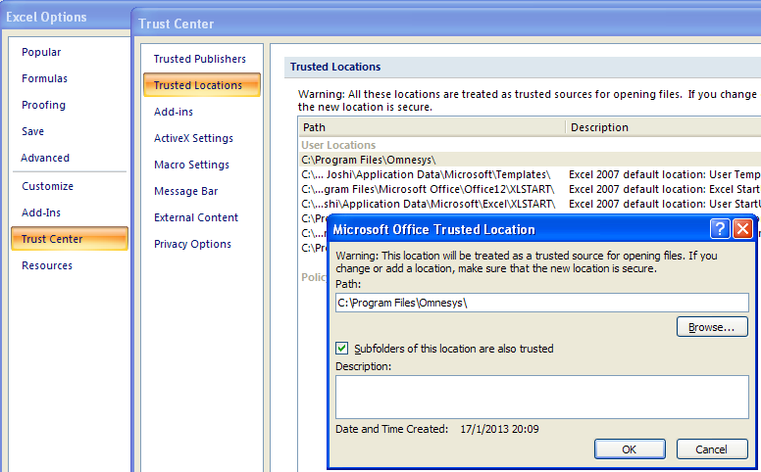

# Setup for AmiBroker Users-

1. Before trying anything in AmiBroker, create new database e.g. C:\AmiBroker\RTdata.
2. Give database folder path to create database. Thereafter, do all the settings as shown above. Those who want to combine EOD data should check against -Allow mixed EOD/Intraday data in Intraday settings.
3. **GoTO Tools Preferences-Do settings in preferences as shown below.**

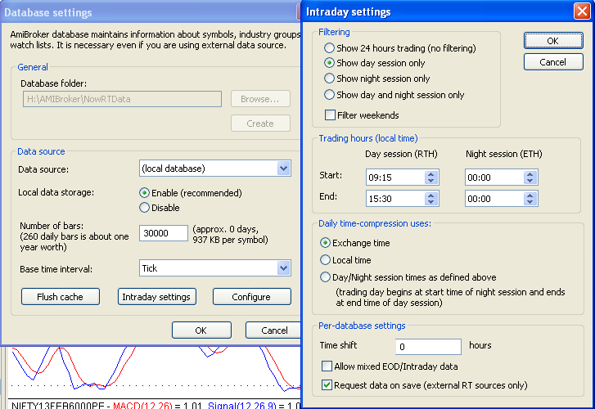

# GETTING REAL TIME DATA FEED TO EXCEL

# Yahoo to Excel

1. This option is available in RTYahoo.xlsm. Yahoo gives realtime quotes for ^NSEI that is Nifty only. Rest of the quotes are 20 minutes delayed, useless for intra-day trading. Hence, I use it to get realtime chart of Nifty only.
2. This utility was built with the help of Gummy-stuff.org. The url of the site and url of Yahoo from where quotes are fetched is given in the sheet.
3. Open your browser and login into Yahoo. The utility will do rest of the work. Yahoo does not give RT quotes. Login is done to ensure that Yahoo does not block you from accessing their site.
4. Open Excel by clicking Start-Programs-Microsoft Office-Excel2007
5. A blank workbook opens with name book1. Ignore it and Open RTYahoo.xlsm from within Excel. Change the database path to Your\AMIBROKER Database\folder\Path
6. **If you installed RAM disk, then give Drive Letter in Cell B2 other wise leave it blank.**
7. **Click on “Start RT Data”.**
8. **AmiBroker Should open automatically and you will see live charts moving**

# Google Finance to Excel

1. Thanks to Ramdas for his site - > <http://niftyfno.forums-free.com/google-realtime-intraday-backfill-data-t40.html> where he has given all the URLs of Google from which data can be obtained.  
     
   RTGoogle.xlsm fetches Google RT feed from this URL:-   
     
   "http://finance.google.com/finance/info?client=ig&q=NSE:IDFC,NSE:ACC"  
   you can just add more script ,NSE:ScriptName
2. I compared the time lag in Realtime quotes from each source and found that the above URL gives quotes within a time lag of 2-3 seconds which I feel is quite acceptable.
3. There is no limit to the number of scrips that can be monitored.
4. Realtime Quotes of other exchanges can also be obtained. Keep database for each exchange separate as their working hours are different.
5. Open your browser and login into Google. The utility will do rest of the work. Login is done to ensure that Google does not block you from accessing their site.
6. Open Excel by clicking Start-Programs-Microsoft Office-Excel2007
7. A blank workbook opens with name book1. Ignore it and Open RTTiger.xlsm from within Excel. Change the database path to Your\AMIBROKER Database\folder\Path
8. **If you installed RAM disk, then give Drive Letter in Cell B2 otherwise leave it blank.**
9. **Click on “Start RT Data”.**
10. **AmiBroker Should open automatically and you will see live charts moving**
11. There are three down sides -  
    1. FnO quotes are not available.  
    2. Volume is not available through this URL   
    3. Data comes in text format. It has to be processed. Hence there is some processing overhead. I have kept the time interval for refreshing at 5 seconds.

# Getting Realtime Feed to AMIBroker

1. Once you start getting realtime quotes in Excel, next step is to get them in AmiBroker and see the charts moving. Your source can be any of NOW, Odin. Trade Tiger, Yahoo or Google. Method of feeding data to AmiBroker is similar. Here is a snapshot of RTNOW.xlsm.
2. **If you installed RAM drive, then give Drive Letter in Cell B2 other wise leave it blank . If you are not sure what is RAM Drive, keep this field blank**
3. **Give Your\Database\Path in cell B1.**
4. **Click on “Start RT Data”.**
5. **AmiBroker Should open automatically and you will see live charts moving**

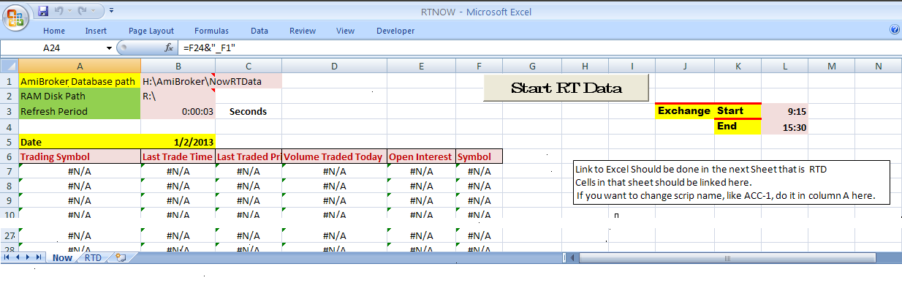

# Realtime feed to FCharts..........

1. FCharts is another application for stock charting. There are two versions of this application. 1. FChartSE is free for all users and 2. FChartPRO is paid versions. I had used the free version about two years ago. I found some discrepancies in weekly charts. That is why and also because I had money to spend, I bought AmiBroker. I installed the latest free version about a month ago. It seems to have improved a lot and added some excellent facilities in two years. New Traders are advised to use this application. FchartSE is very easy for intraday charts.
2. All the files of type *.xlsm work out of the box with FCHARTSE the free charting software.
3. Those who are not getting Last Traded time in data feed(diet ODIN) will have to click on "Start RT Data" to get current time. All others just have to start data feed application like NOW or NEST and get realtime feed to FChartSE.
4. Open NOW or Nest or which ever software
5. Open RTNOW/RTNest/RTGoogle/RTYahoo/RTODIN/RTTiger.xlsm whichever you want and check whether rates are changing. (Trust Centre settings to be done as given earlier in this thread)
6. We will have to add Date Column since it needs that. Do not add any column. Use the "Symbol" column instead. Erase its contents and type "=Today()" without quotes against each scrip in that column.
7. Open FChartSE
8. Click on Intraday and select Excel as source.
9. Click on Refil List and It will show the name of excel file.
10. Column settings as given in the image. They are self explanatory.
11. 1st Data Row in our case is 7.
12. **Click on “Start“. You can see one minute bars getting updated live in FCharts.**

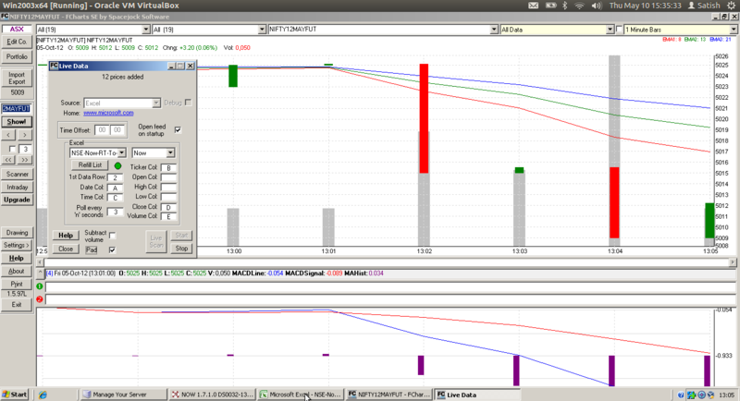

# Backfill with Data Downloader

1. Data Downloader is created by Joydeep Mitra and it is hosted on Volumedigger.com.
2. A video is hosted on You tube for backfill. Link is here- <http://youtu.be/A65Si2KpK_s>
3. Apart from the video, do following settings in Data Downloader

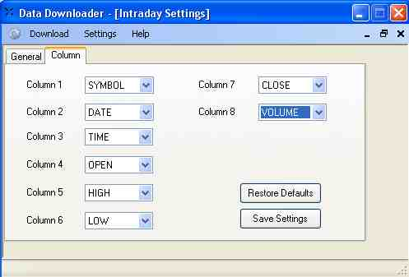

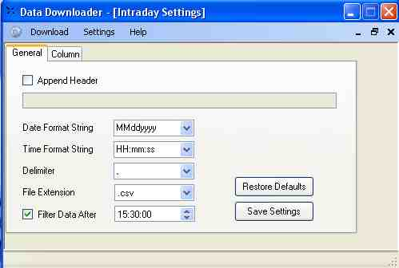

1. You can link Nest sheet the symbol will be RELIANCE-EQ, use following formula :

=IF(RIGHT(RTD!A13,3)="FUT",RTD!F13&"_F1",IF(RIGHT( RTD!A13,3)="-EQ",RTD!F13&"",RTD!A13))

1. and now the symbol will exact match of NSE symbol i.e. RELIANCE,
2. after that using © Joydeep Mitra DataDownloader,

format the intraday download as per nest column along with date i.e. dd/MM/yyyy ,

1. Edit google intraday.txt. Add the scrips (symbol should be exact as per NSE along with .NSE i.e. RELIANCE.NSE) ,
2. Download intraday data from ->INTRADAY->GOOGLE ,
3. Import all txt files in amibroker using import wizard. Save the format as “Google Intraday”.
4. BINGO all scrips backfill done in seconds.
5. Next time use “Google Intraday” format and import ASCII.

# Troubleshooting

1. I am not too good in computer related stuff, please help me.

You need not be good in computers to follow this. Follow all the instructions. If you do not understand any instruction, ask me. Sorry, I cannot do spoon feeding. Please help yourself first and thereafter I will help you.

1. I did everything as per instructions but I am not getting charts. Please help.

What do you mean by that. I cannot help you with one line information. Check whether you followed all the steps as given. Give me the exact step where you are not getting desired results and ask specific question.

1. Backfill is not happening.

What do you mean by that. I cannot help you like that. Check whether you followed all the steps as given and ask specific question. You do database setting only once. Be sure that you give same database path to RT utility and Backfill utility.